Module Name: Login Page - Functional & UI Test Case
Test Case ID: TC_LOGIN_001
Webpage URL: https://opensource-demo.orangehrmlive.com/web/index.php/auth/login

Scenario ID: 1A
Scenario: Login with valid credentials
Test Steps:
- Open the OrangeHRM Login page
- Enter a valid username
- Enter a valid password
- Click on Login
Screenshots :

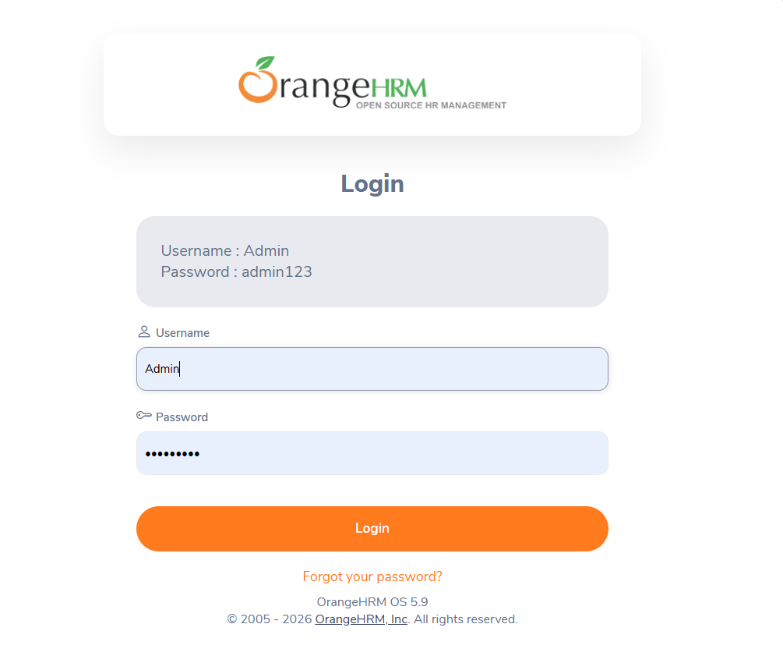

Scenario ID: 2A
Scenario: Confirm login
Test Steps:
1. Dashboard shown
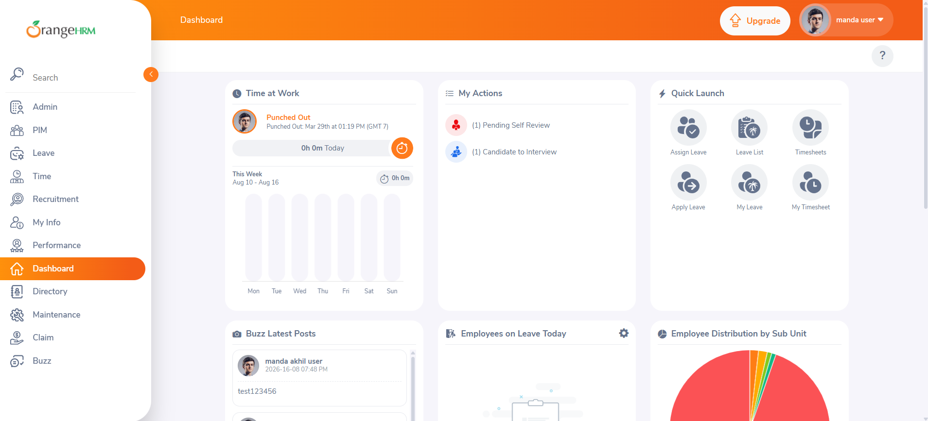

Scenario ID: 2B
Scenario: Explore dashboard
Test Steps:
- Click on Admin in the navigation
- Explore it

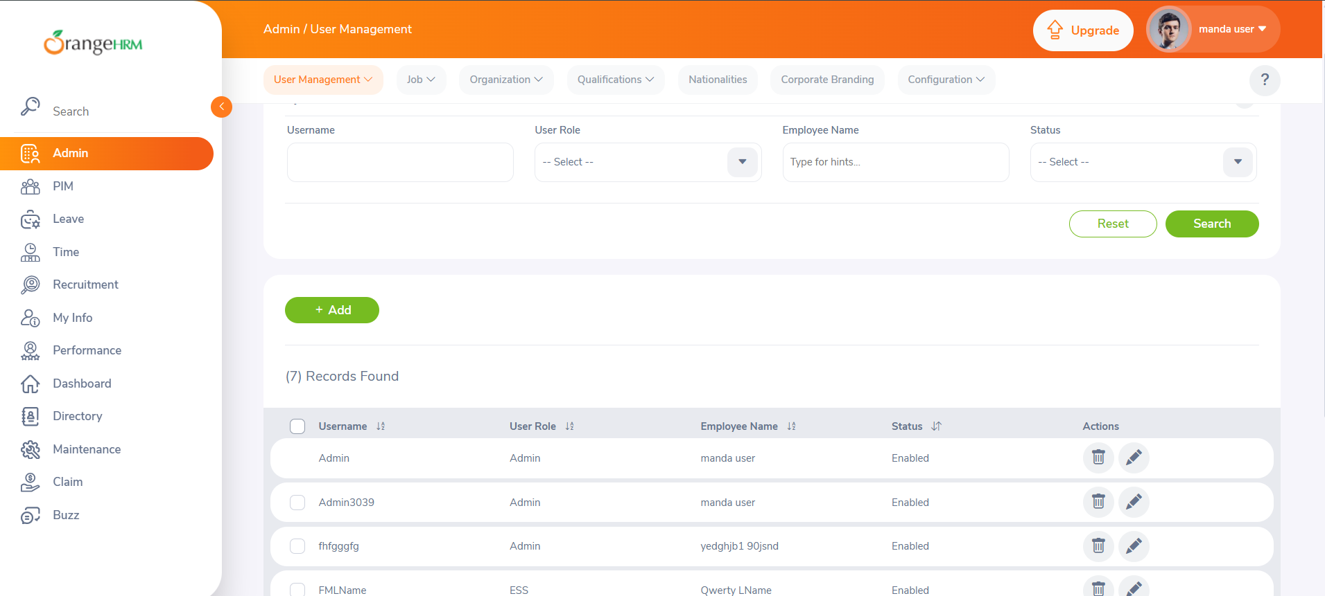

Scenario ID: 2C
Scenario: Explore my info
Test Steps:
- Click on My Info in the navigation bar
- Explore it

